Session 3

Topic: Exclusive Joins - Edge Cases Handling (NULL Handling)

List the Products Ordered in a Period:
Ques 1 : You are given two tables:
• Products: product details
• Orders: units ordered on different dates
Your task:
Find product names whose total ordered units in February 2020 (2020-02-01 to 2020-02-29) are at least 100, and also show their total units.

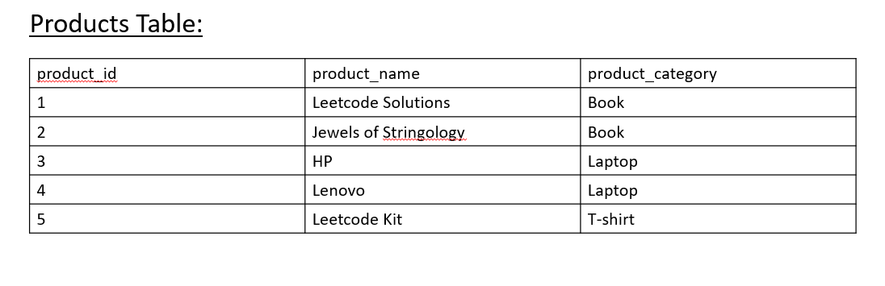
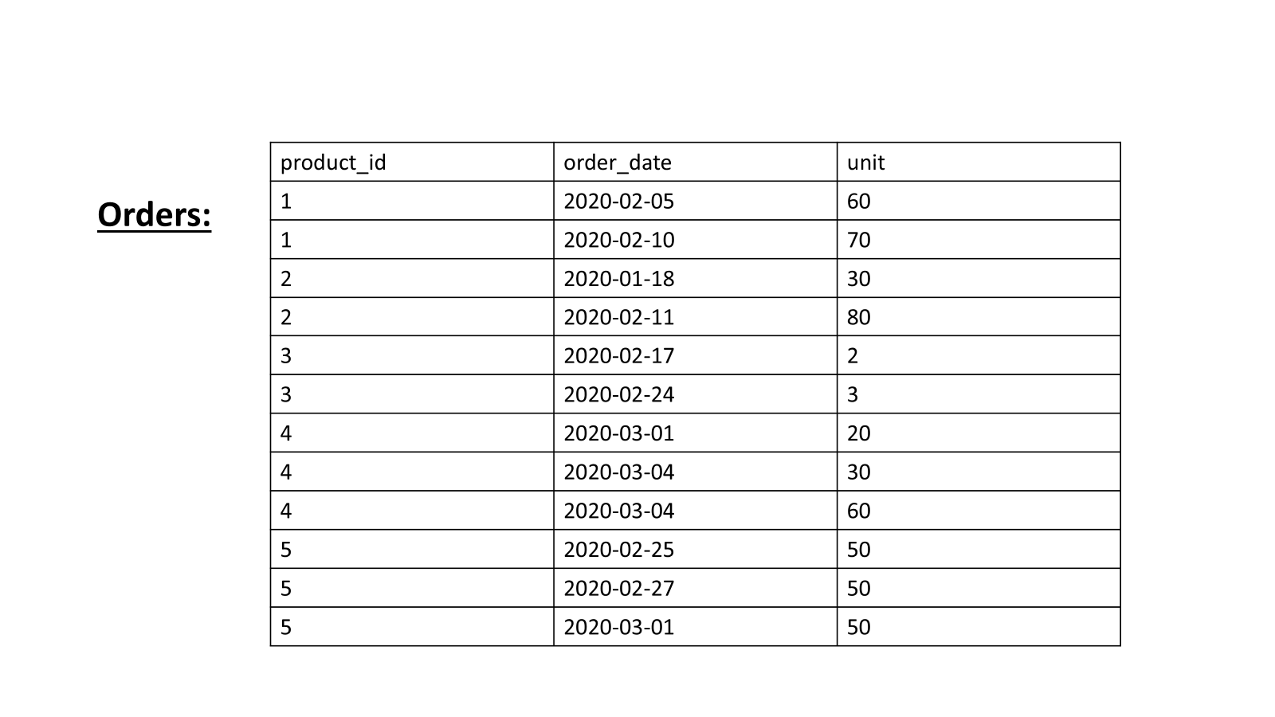

Output:

CREATE TABLE Products (
product_id INT PRIMARY KEY,
product_name VARCHAR(100),
product_category VARCHAR(50)
);
INSERT INTO Products (product_id, product_name, product_category) VALUES
(1, 'Leetcode Solutions', 'Book'),
(2, 'Jewels of Stringology', 'Book'),
(3, 'HP', 'Laptop'),
(4, 'Lenovo', 'Laptop'),
(5, 'Leetcode Kit', 'T-shirt');
CREATE TABLE Orders (
product_id INT,
order_date DATE,
unit INT,
FOREIGN KEY (product_id) REFERENCES Products(product_id)
);
INSERT INTO Orders (product_id, order_date, unit) VALUES
(1, '2020-02-05', 60),
(1, '2020-02-10', 70),
(2, '2020-01-18', 30),
(2, '2020-02-11', 80),
(3, '2020-02-17', 2),
(3, '2020-02-24', 3),
(4, '2020-03-01', 20),
(4, '2020-03-04', 30),
(4, '2020-03-04', 60),
(5, '2020-02-25', 50),
(5, '2020-02-27', 50),
(5, '2020-03-01', 50);

Approach 1

SELECT product_name, SUM(unit) AS unit
FROM Orders AS o
INNER JOIN Products
USING(product_id)
WHERE TO_CHAR(order_date, 'YYYY-MM') = '2020-02'
GROUP BY product_id, product_name
HAVING SUM(unit) >= 100;

Approach 2:

SELECT p.product_name, SUM(o.unit) AS unit
FROM Orders o
JOIN Products p ON o.product_id = p.product_id
WHERE o.order_date BETWEEN DATE '2020-02-01' AND DATE '2020-02-29'
GROUP BY p.product_id, p.product_name
HAVING SUM(o.unit) >= 100;

Ques 2:
• Write an SQL query to find students who are not enrolled in any course.

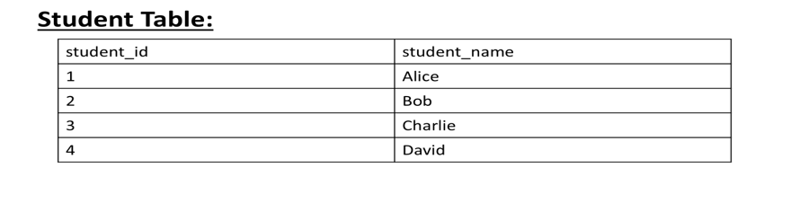

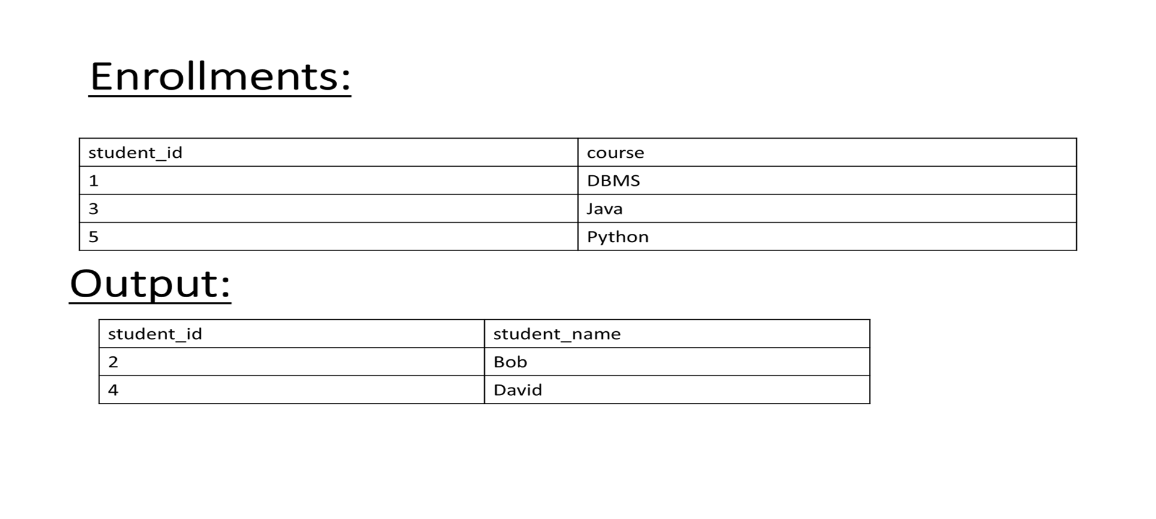

Solution:

CREATE TABLE Student (
student_id INT PRIMARY KEY,
student_name VARCHAR(50)
);

CREATE TABLE Enrollments (
student_id INT,
course VARCHAR(50)
);

INSERT INTO Student (student_id, student_name) VALUES
(1, 'Alice'),
(2, 'Bob'),
(3, 'Charlie'),
(4, 'David');

INSERT INTO Enrollments (student_id, course) VALUES
(1, 'DBMS'),
(3, 'Java'),
(5, 'Python');

Solution:

Approach 1:

SELECT
s.student_id,
s.student_name
FROM Student s
LEFT JOIN Enrollments e
ON s.student_id = e.student_id
WHERE e.student_id IS NULL;

Approach 2:
SELECT
student_id,
student_name
FROM Student
WHERE student_id NOT IN (
SELECT student_id FROM Enrollments
);

